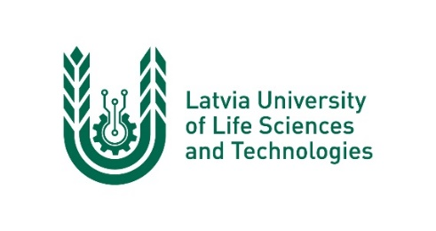
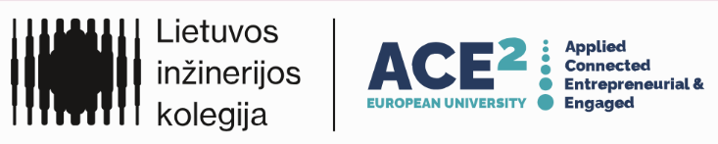

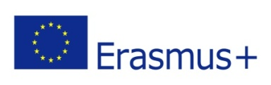

Blended Intensive Programme

Latvia University of Life Sciences and Technologies in cooperation with Lietuvos Inžinerijos Kolegija | Higher Education Institution and Isparta University of Applied Sciences
Organise a course for graduate and undergraduate students
From Abundance to Water Scarcity: Climate Variability and Anthropogenic Risks
6 ECTS

25th-29th May 2026
Venue: Jelgava, Latvia

Duration:
6 ECTS
Online phase: 11-22 May 2026
Intensive week in Latvia: 25-29 May 2026
Target Group:
Bachelor’s, Master’s and PhD students in environmental engineering, agricultural engineering, hydrology, water management, and climate sciences.

Aim:
The aim of the course is to develop interdisciplinary understanding and practical skills for assessing, modelling, and managing water scarcity and abundance under climate variability and anthropogenic pressure, integrating natural sciences, engineering, and socio-economic perspectives.

Learning Outcomes:
After completing the course, students will be able to:
- Explain climate-driven hydrological extremes and anthropogenic pressures on water systems.
- Apply data analysis and modelling tools to assess water scarcity and flood risks.
- Evaluate water management strategies in the context of sustainability and resilience.
- Collaborate effectively in international, interdisciplinary teams using digital and field-based methods.

Phase 1 – Online (11-22 May 2026)
Format: Moodle + MS Teams
Activities include introductory lectures, GIS and data analysis training, and short assignments.
Deliverable: Essay “Water challenges in my country.”

Phase 2 – Intensive Week in Latvia (25-29 May 2025)
Location: Jelgava + field visits (Svete River basin, Lielupe floodplain)
Activities: Workshops, modelling exercises, fieldwork, laboratory analyses, and group projects.
Deliverable: Group poster and report “Integrated Water Management Strategy.”

Teaching and Learning Methods:
- Blended learning (online + field + laboratory)
- Problem-based learning (case study approach)
- Group collaboration and interdisciplinary teamwork
- Field observations and laboratory work
- Use of digital tools: QGIS, Excel, Python basics, WEAP/METQ modelling

Assessment:
Component | Description | Weight
Online essay | “Water challenges in my country” | 10%
Group work (poster & report) | Integrated case study results | 40%
Field & lab participation | Practical engagement | 20%
Final presentation | Group results presentation | 20%
Reflection report | Individual assessment of learning | 10%

Programme on site

Sunday, 24th of May
Arrival in Jelgava and hotel check-in (students cover accommodation and meal expenses).
Evening informal meeting and welcome by course coordinators.
Facilitators: Linda Grinberga.

Monday, 25th of May
Akademijas str. 11
5th floor Conference room
9.30 – 9.40 The welcome speech Dean of the Faculty of Forest and Environmental Sciences
9.40 - 10.50 The Ice breaking activity and short introduction to our self’s (Linda Grinberga)
10.50 -11.00 Splitting in international multidisciplinary groups and establishment of working space for each group
11.00-11.30 Coffee break
11.30-12.00 Lecture Sustainable development goals and strategies relevant to enhancing water resilience in the Baltic Sea Region (Inga Grinfelde)
12.00-14.00 Lunch break
14.00-17.00 Excursion to Jelgava Wastewater Treatment Plant (departure from Akademijas 11). Lecturers accompany groups, facilitate thematic discussions, and lead reflection afterwards (Linda Grinberga, Inga Grinfelde, Vilda Grybauskienė, Ulas Senyigit).

Tuesday, 26st of May
Akademijas str. 11
4th floor room Nr.46
09.30-12.00 Lecture: Sustainable Water Management in the Baltic Sea and Mediterranean Regions: Comparative Case Studies (Vilda Grybauskienė & Ulas Senyigit

12.00-14.00 Lunch break
14.00-17.00 Lecture: Adapting to Water Scarcity and Resource Challenges: Comparative Perspectives from Turkey and the Baltic Region (Ulas Senyigit& Vilda Grybauskienė)
Group work: Identifying environmental problems and proposing eco-innovation solutions. Continuous consultation and mentoring (Ulas Senyigit & Vilda Grybauskienė).

Wednesday, 27th of May

09.00-19.00 Field trip to Riga city the identification of water management problems and evaluation of need for innovations. The field visit materials uploaded on platform. All lecturers accompany students, provide thematic guidance, and evaluate observation tasks. Afternoon and evening reflection on platform, moderated by Gitana Vyčienė (joins from this day, continuous consultation from all lectures group).

Thursday, 28th of May
Akademijas str. 11
4th floor room Nr.46
09.30-13.00 Students in groups prepare a concept of Integrated Water Management Strategy. (moderator Ulas Senyigit and Gitana Vyciene)
13.00-14.00 Lunch break
14.00-15.30 Students in groups prepare a concept of Integrated Water Management Strategy. (moderator Inga Grinfelede and Ulas Senyigit)

15.30-16.00 Coffee break
16.00-17.00 The preparation of presentations by groups. (moderator Linda Grindberga and Inga Grinfelde)

Friday, 29th of May
Akademijas str. 11
2nd floor room Nr.28
09.30-12.00 Students in groups prepare a concept Integrated Water Management Strategy. Individual mentoring and feedback sessions with all lecturers (Inga Grinfelde, Linda Grinberga, Vilda Grybauskienė, Gitana Vyčienė, Ulas Senyigit).
12.00-14.00 Lunch break
14.00-15.30 Presentation of groups results concept of Integrated Water Management Strategy. Each student gives a personal reflection; lecturers provide expert evaluation and feedback (panel: all lecturers)
15.30-16.00 Coffee break
16.00-17.00 The official closing ceremony and certificates for attendees. Closing remarks and summary by lecturers and Dean (Linda Grinberga, Inga Grinfelde, , Ulas Senyigit, Gitana Vyčienė, Vilda Grybauskienė)

Saturday, 30th of May
Departure to home.

